

**Cisco Aironet 1852E**

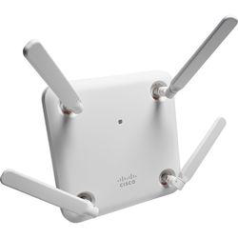

Punto de acceso inalámbrico

* 802.11ac Wave 2 (draft 5.0)
* 802.11a/b/g/n/ac Wave 2 (draft 5.0)
* Banda doble
* CA 120/230 V / CC 44 - 57 V

**Notebook Dell 3459**

Intel® Core™ i5-6200U caché de 3 M, 2.3 GHz

4GB (1x4GB) 1600MHz DDR3L Memory Intel® HD Graphics 520

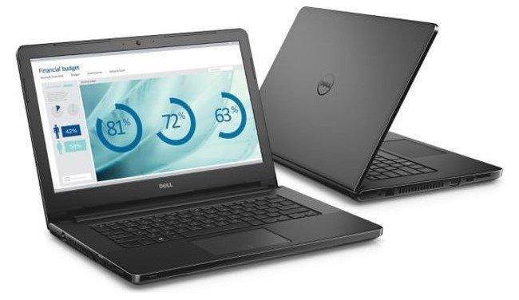

500GB 2.5inch SATA (5,400 Rpm) Hard Drive

Windows 10 Home, 64-bit. NO posee DVD Drive

802.11ac + Bluetooth 4.0, Dual Band 2.4&5 GHz, 1x1

40 WHr, 4-Cell Battery (integrated)

14.0" HD Wide Screen LED Anti-Glare Display (1366x768) 720p

Black LCD cover(integrated Widescreen HD 720P Webcam with Dual digital microphone array)

45W AC Adapter, 3Pin

IFTS Nº12 | Pág. 68

